Sony Viewfinder HD-SDI Adapter Board

The Board will convert HD-SDI from a BNC and convert it to Y, Pb, Pr. This output can then be used on an HDVF-20A Sony Viewfinder.

The board will also provide Power to the viewfinder and pass a Red and Green Tally to the Viewfinder.

The Initial HD-SDI is also Looped back out on a second BNC. This may then be used for an RF- Link or a second monitor or external recording device. This loop-out is also a re-clocked output.

There are three boards;

- Main Video Converter
- Viewfinder Connector
- Power & Tally Connector

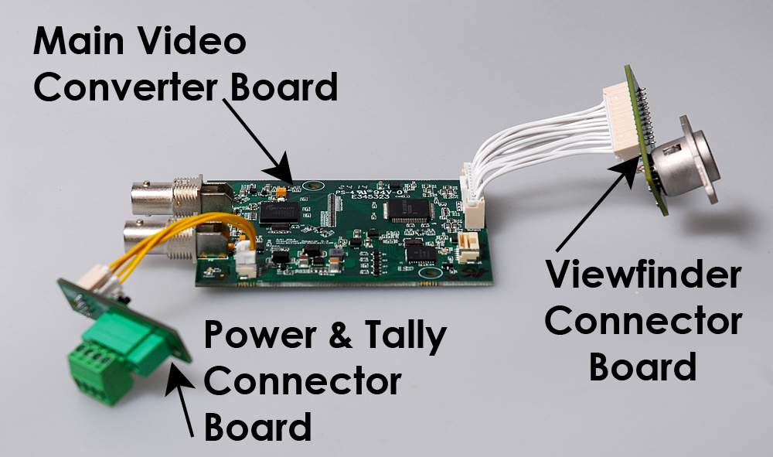

The Viewfinder Connector Board has been tested with a Sony HDVF-20A Viewfinder.
Pin OUTS

The Main Video Converter Board has two board mounted BNCs. The top BNC is the HD-SDI Input and the lower BNC is a Loop Out/Through. (See photo)

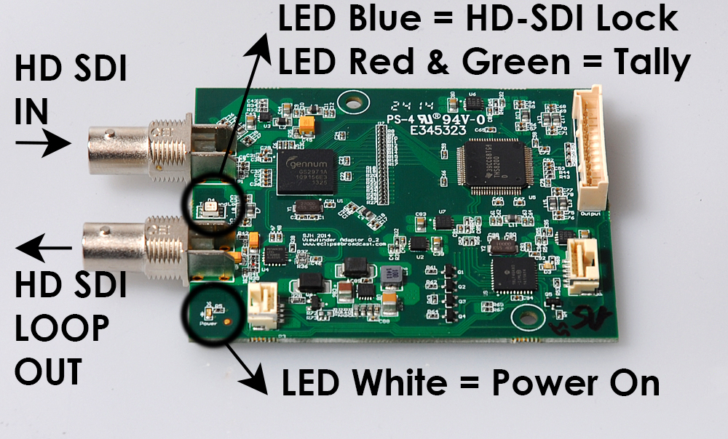

On the Power & Tally Connector Board there is a 4 Way Connector with the following pin outs (see photo);

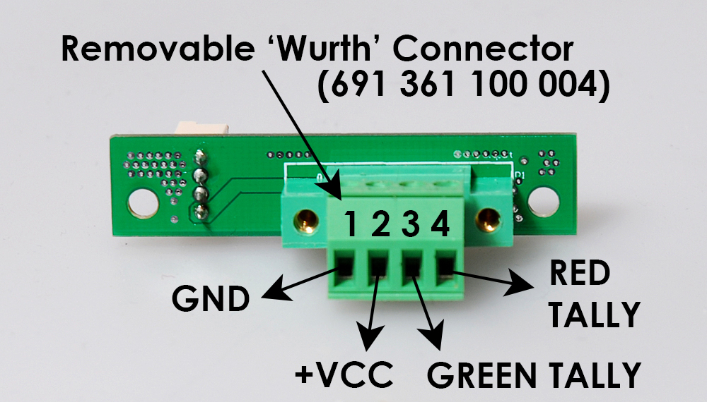

Pin 1 = GND
Pin 2 = +VCC Min Voltage: 10.5 VDC,
Max Voltage: 17 VDC
Elite IDX battery – Maximum output (no load) is initially 17.5 VDC. There is a blocking diode on Viewfinder output, so it is not a problem to use an Elite IDX battery @ 17.5VDC.
Pin 3 = Green Tally
Pin 4 = Red Tally

Tallies/Cues

The Tally board has a small switch on it to select Tally Type (see photo);

Up position – This is for a Tally that is ‘ON’ when there is a ‘Short to Ground’ e.g. VideoSyS Data

Down Position - This is for a Tally that is ‘ON’ when a there is a +VE e.g. Total RF (TRF) Data/Gigawave

A Tally with appear in the Viewfinder for the camera-operator to see but also note that there is also a Tri-Colour LED ‘Confidence’ Tally on the Main Video Board. See the first Photograph. Blue will show HD-SDI Video lock, and Red and Green for respective Tallies.

